**CS607 Assignment #1 Spring 2024**

Name: Abdul Rehman

VU-ID: BC220424444

**Question #1:**

Consider the following tree, use simple search algorithm (given on page# 24 of handouts) and apply the Depth First Search (DFS) strategy. The starting node is 1, and the goal node is 7. You are required to fill out only the given Table.

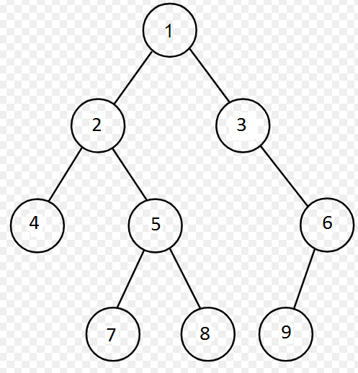

**Solution:**

|  |  |  |
| --- | --- | --- |
| **Sr No** | **Q - List** | **Visited List** |
| **1** | 1 | 1 |
| **2** | 2, 3 | 1, 2, 3 |
| **3** | 4, 5, 3 | 1, 2, 3, 4, 5 |
| **4** | 5, 3 | 1, 2, 3, 4, 5 |
| **5** | 7, 8, 3 | 1, 2, 3, 4, 5, 7 |
| **6** | 8, 3 | 1, 2, 3, 4, 5, 7 |

**Question #2:**

Breath First Search (BFS) is a memory hungry search strategy which means it requires a lot of memory whiling processing a problem even having a reasonable and moderate complexity. It is primarily due to the branching factor that increase the number of ways to search for the solution (goal/target).

Now, consider that we have a tree with the branching factor of 4 and depth (or height) 12, while each node requires 16 bytes storage. If the Breath First Search (BFS) is applied to this tree, then calculate the memory required for this search.

**Note:** Provide complete steps while calculating the memory storage.

**Solution:**

The branching factor = 4.

Depth = 12.

Each Node Storage = 16 bytes.

Now,

The max number of nodes in the queue = 412 = 16,777,216.

Memory required = 16 x Max number of nodes in the queue.

= 16 x 16,777,216.

= 268,435,456 bytes.

**Memory required = 268 MBs.**

**Conclusion:**

If the Breath First Search (BFS) is applied to this tree, then Memory required for this search will be 268Mbs.